**Data Analyst Assignment**

**by AnimeMangaToon**

**Personal Detalis:**

Name:Naimish Mishra

Mail: [naimishmishra.work@gmail.com](mailto:naimishmishra.work@gmail.com)

Portfolio Link: <https://naimish.niwaarcade.site>

Linked in :  [Naimish Mishra | LinkedIn](https://www.linkedin.com/in/naimishmishra/)

Contact Number: +91 6207721981

### 

### 

### 

### 

### 

### 

### 

### 

### 

### 

### 

### 

### **Table of Contents**

| Premise and Assumptions About Data | Page 3 |
| --- | --- |
| Screenshot of Dashboard | Page 3-4 |
| Analysis Summary of Tower of Gods | Page 5-7 |
| Analysis Summary of Refund High School | Page 8-11 |
| Analysis for Best Solo Levelling Arcs | Page 12-15 |
| Conclusion | Page 15 |

### 

### 

### 

### 

### 

### 

### 

### 

### 

### 

### 

### 

### 

### 

### 

### **Premise and Assumptions About Data:**

**Hello**, Recruiter. Naimish here. I am submitting my assignment for the web page analysis provided by AnimeManga Toon.

The insight report, including relevant KPIs and graphs, is shared in this PDF, and I have also built the Power BI dashboards for further analysis, if required.

You can access it via Github Link or Google Drive Link Provided.

**Github:**

https://github.com/Naimish2003/AnimeMangaToon-Assignment-

**Drive:** https://drive.google.com/drive/folders/1tNdYwfjaWqd0tR40_YHuMFjubITZFdlr?usp=sharing

**IMPORTANT**

Since the data was not provided, I replicated the dataset using AI and Python, making efforts to keep it as natural as possible. However, some abnormalities may still be present due to the randomness, as I was constrained by time. I apologize for any inconsistencies.

Thank you.

### **ScreenShot of Dashboards:**

### **11 Best Solo Levelling Arcs**

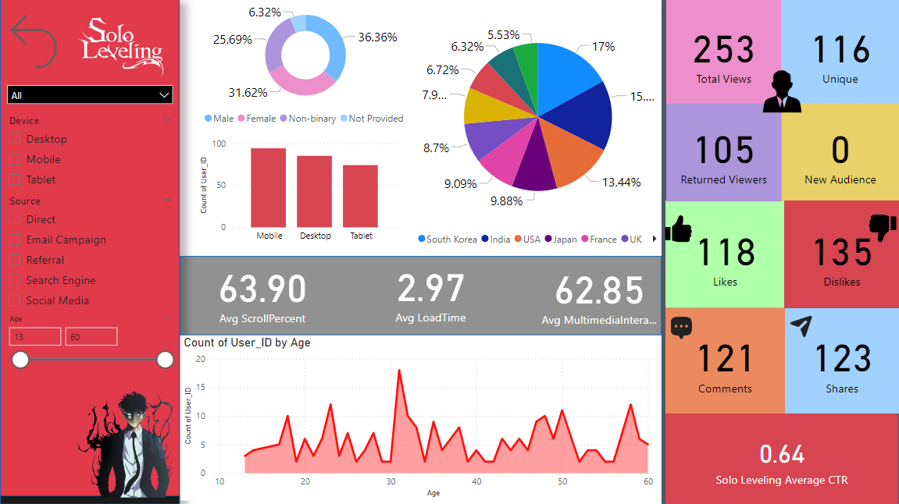

1. **Why is the Tower of God Show So Popular?**

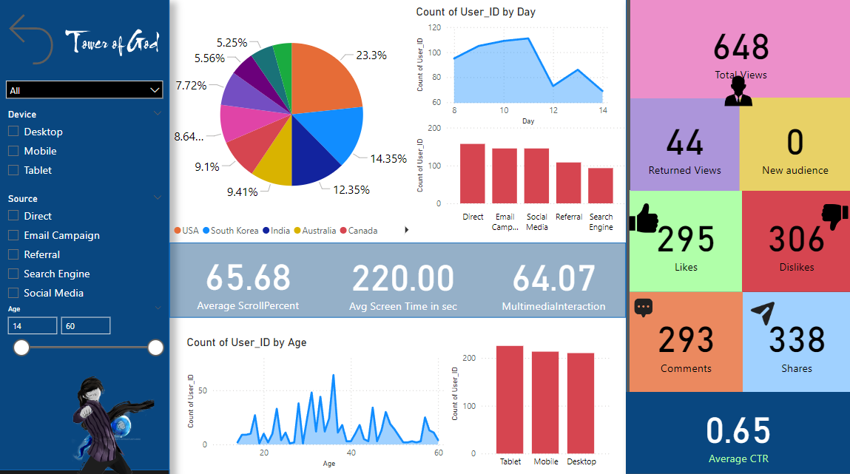

### **Refund High School Chapter 22**

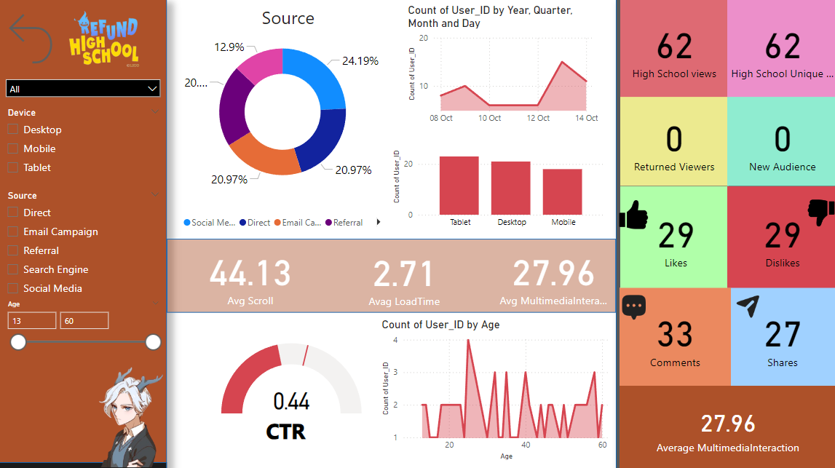

### 

### **Analysis Summary: *"Why is the Tower of God Show So Popular?"***

**OBJECTIVE:**

Review the article “Why is the Tower of God Show So Popular?” and imagine it has user data such as page views, average time spent, and bounce rate. Analyze these metrics and create visualizations (bar graphs, pie charts) to identify engagement trends

* **Location Stats**:
* 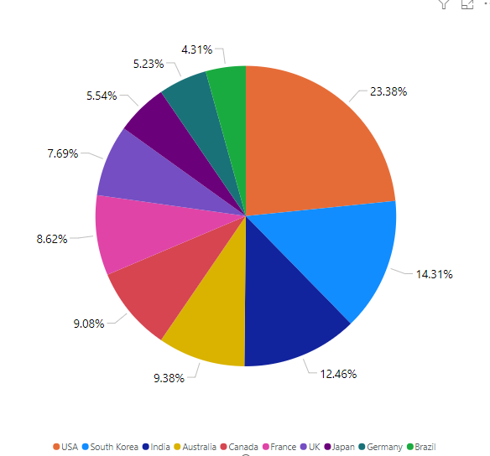
  + Highest viewership from the USA (152), South Korea (93), and India (81).
  + Surprisingly low engagement from anime-heavy markets like the UK (50) and Japan (36).
  + Germany (34) may be impacted by language barriers.
* **View Stats**:
  + Total views: 650
  + Returned viewers: 44,
  + **0 users.**
  + **Viewership by Day**: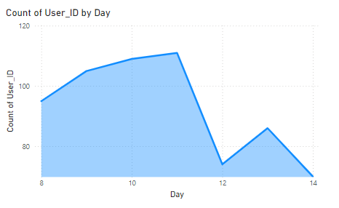
    - Day 8: 95 users
    - Day 9: 105 users
    - Day 10: 109 users
    - Day 11: 111 users
    - Day 12: 74 users
    - Day 13: 86 users
    - Day 14: 70 users

**Decline in interest** : After Day 11 suggests possible viewer fatigue or lack of ongo

* **Feedback Stats**:
  + Comments: 293, Shares: 338
  + Likes (297) nearly match dislikes (306), indicating a divided audience reaction.
* **Technical Stats**:
  + Average scroll percentage: 65.1%
  + Average screen time: 219.94 seconds
  + Average CTR (Click-Through Rate): 0.65%, indicating low user action.
* **Device Stats**:
  + Balanced device distribution: Mobile (214), Computer (211), Tablet (225).
* **Source Stats**:
  + Key traffic sources: Direct (158), Mail (145), Social Media (145).
  + Low referral traffic (108) despite a high number of shares (338).
  + Weak search engine performance (94), suggesting poor SEO optimization.

### **Suggested Improvements:**

1. **Address Viewer Drop-off**: Introduce engaging content or features to maintain interest beyond Day 11.
2. **Attract New Users**: Implement strategies to drive new user acquisition.
3. **Optimise for Key Markets**: Increase marketing efforts in regions like the UK and Japan to leverage their strong anime audience base.
4. **Improve SEO**: Focus on strengthening search engine optimization for better discoverability.
5. **Enhance Engagement**: Address the split audience sentiment by offering more targeted content or interaction features.

**Based on the analysis, here are two additional strategies to increase the average time spent on the page:**

Although media interactivity is already high at 64.15%, expanding interactive content can further engage users.

1. **Interactive Content and Media Integration:** Embedding quizzes, polls, or character deep dives related to *Tower of God* could hold the audience's attention longer. Offering exclusive content such as interviews or behind-the-scenes footage could entice viewers to explore the page in more depth and increase their time on-site.
2. **Implement a Multiple Language System** (with reference to Germany): Germany's relatively low viewership (34 users) could be due to language barriers. Introducing a multilingual system, especially offering the page in German and other languages, could improve accessibility and encourage longer engagement from international users.

### 

### 

### 

### 

### 

### 

### 

### 

### 

### 

### 

### 

### 

### 

### **Analysis Summary of "Refund High School Chapter 22"**

**OBJECTIVE:**

Analyse user interaction data for “Refund High School Chapter 22-30: The New Arc of Mook” and propose an A/B testing strategy. Recommend content changes to test (e.g., different headlines, visuals) that may improve user retention and reduce bounce rate.

#### **Location Statistics**

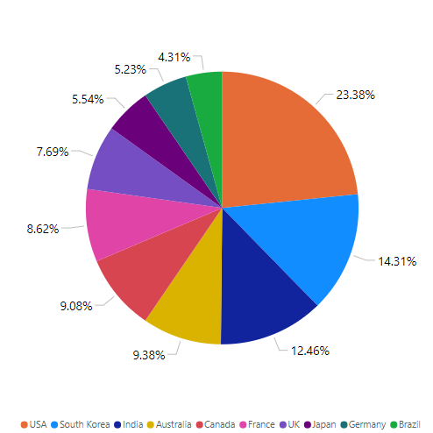

The viewership distribution is as follows:

* **South Korea**: 9
* **India**: 7
* **USA**: 2
* **Australia**: 4
* **Canada**: 7
* **France**: 7
* **UK**: 7
* **Japan**: 7
* **Germany**: 4 may be impacted by language barriers.
* **Brazil**: 8

This geographical spread indicates a diverse audience, with South Korea having the highest viewership.

While Germany Still Struggling with the audience possibly due to language barrier

#### **View Statistics**

* **Total Views**: 62
* **Returned Viewers**: 0
* **New Users**: 0

The absence of returning and new users suggests a need for content improvement to attract and retain viewers.

#### **Feedback Statistics**

* **Comments**: 33
* **Shares**: 27
* **Likes**: 29
* **Dislikes**: 29

The feedback indicates a mixed reception, with dislikes matching likes. This ratio signals potential issues with content quality or viewer expectations.

#### **Technical Statistics**

* **Average Scroll Percentage**: 44.13 (indicating potential issues with content engagement)
* **Media Interaction Rate**: 27.96 (very low)
* **Average Click-Through Rate (CTR)**: 0.44 (very low)

The low scroll percentage and media interaction rates suggest that viewers may not find the content engaging, which can lead to decreased retention.

#### **Device Statistics**

* **Mobile**: 18 views (Load time: 2.97 seconds)
* **Computer**: 21 views (Load time: 2.71 seconds)
* **Tablet**: 23 views (Load time: 2.52 seconds)

Load times are slightly higher than usual, especially for mobile users. This may impact user experience and engagement.

#### **Age Statistics**

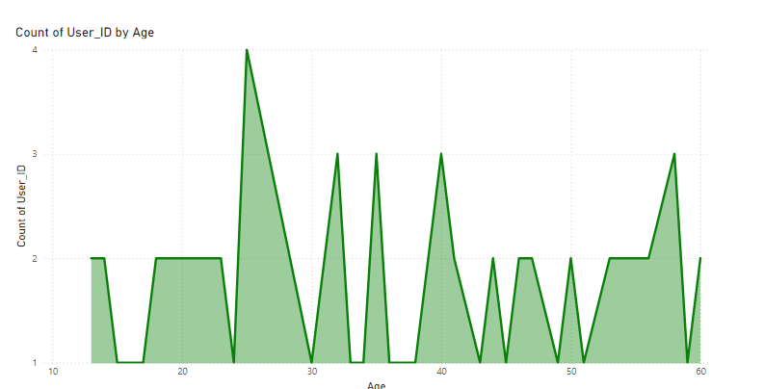

The audience is well-distributed across age groups from under 18 to 60, indicating the potential relevance of the content to a broad demographic.

#### **Source Statistics**

* **Direct Traffic**: 13
* **Email Traffic**: 13
* **Referral Traffic**: 13 (total shares: 338)
* **Search Engine Traffic**: 8 (indicating weak SEO performance)
* **Social Media Traffic**: 15

The distribution of traffic sources highlights the effectiveness of direct and social media traffic but reveals a need for improved SEO strategies to increase organic search visibility.

#### **Viewership Trends**

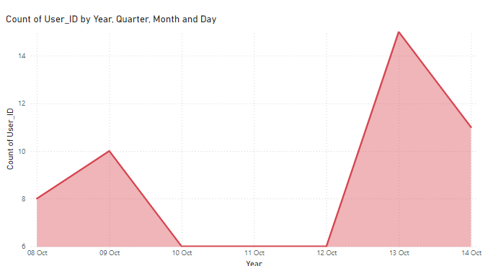

* **October 8**: 8 views
* **October 9**: 10 views
* **October 10**: 6 views
* **October 11**: 6 views
* **October 12**: 6 views
* **October 13**: 15 views
* **October 14**: 11 views

The viewership trend shows a growth pattern, with fluctuations that may reflect engagement with new content or external promotional efforts.

### 

### 

### **Recommendations for Improvement**

1. **Enhance Content Quality**: Address feedback to refine the content and align it better with viewer expectations. Consider conducting surveys to gather more insights from viewers.
2. **Improve SEO**: Invest in better SEO practices to boost visibility in search engines, potentially increasing organic traffic.
3. **Engagement Strategies**: Increase media interactions by incorporating more interactive content, such as polls, quizzes, or engaging visuals.

### 

### **A/B Testing Strategy for "Refund High School Chapter 22-30: The New Arc of Mook"**

#### **Objective**

The goal of this A/B testing strategy is to improve user retention and reduce bounce rates for "Refund High School Chapter 22-30: The New Arc of Mook." Given that I am not well aware of the series, any visual or content changes might have no effect or could even negatively impact the content. Therefore, the focus will be on technical changes that can enhance the user experience and SEO performance.

#### **Proposed Technical Changes to Discuss**

1. **Low Image Quality**:
   * Replace any low-quality images with high-resolution visuals to enhance the overall appearance and professionalism of the content. Higher-quality images can improve user engagement and retention.
2. **Lack of Proper Detailing**:
   * Ensure that each chapter contains sufficient details and context to captivate readers. This may involve adding character backgrounds, plot developments, and thematic elements that can help readers understand the narrative better.
3. **Concise and Efficient Summaries**:
   * Create more concise and effective summaries for each chapter. Well-structured summaries can enhance user comprehension and are beneficial for SEO, helping to attract more organic traffic.
4. **Hyperlinks for In-Depth Understanding**:
   * Add hyperlinks within the text to direct readers to related content or in-depth explanations of key themes, characters, or events. This will provide readers with additional context and enhance their engagement with the material.

### 

### **Analysis for “11 Best Solo Leveling Arcs in the Manhwa”**

**OBJECTIVE:**

Use “11 Best Solo Leveling Arcs in the Manhwa to Read Now” as a case study. Develop a report that outlines user segmentation based on demographics or behavior (e.g., age group, returning vs. new visitors) and suggest ways to tailor content for these segments.

#### **User Segmentation**

1. **Location-Based Segmentation**

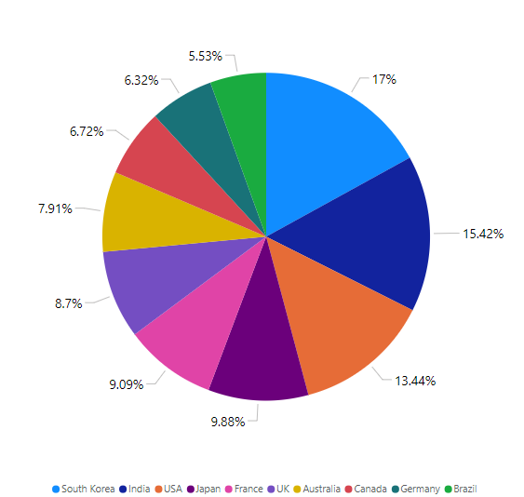

* + **South Korea**: 43 views
  + **USA**: 34 views
  + **India**: 39 views
  + **Australia**: 20 views
  + **Canada**: 17 views
  + **France**: 23 views
  + **UK**: 22 views
  + **Japan**: 25 views
  + **Germany**: 16 views
  + **Brazil**: 14 views

**Insights**: The largest audiences are from South Korea, India, and the USA, indicating a strong interest in "Solo Leveling" in these regions.

1. **Returning vs. New Visitors**
   * **Total Views**: 253
   * **Returned Viewers**: 116
   * **New Users**: 0

**Insights**: A significant portion of the audience consists of returning viewers, showing successful engagement. However, the absence of new users suggests challenges in attracting first-time readers.

1. **Age Distribution**

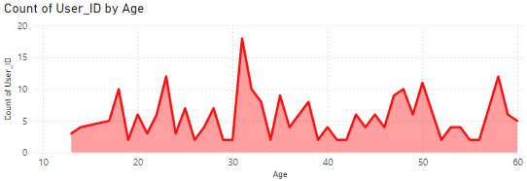

* + Viewership is well-distributed across ages 13 to 60, with the largest segment from 30-40 years old.

**Insights**: This demographic is likely more invested in the content, making them prime targets for deeper engagement strategies.

1. **Gender Demographics**

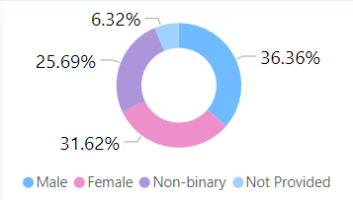

* + **Male**: 36.36%(92)
  + **Female**: 31.62%(80)
  + **Non-Binary**: 25.69%(65)
  + **Not Specified**: 6%(16)

**Insights**: The gender distribution indicates a relatively balanced audience, with a notable percentage of non-binary viewers, suggesting the need for inclusive content that resonates with diverse identities.

1. **Device Usage**

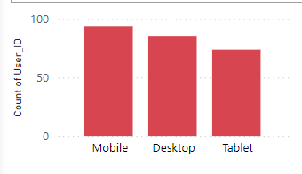

* + **Mobile**: 94 views
  + **Computer**: 85 views
  + **Tablet**: 74 views

**Insights**: The majority access the content via mobile devices, highlighting the need for mobile-optimized content.

1. **Source of Traffic**
   * **Direct Traffic**: 50
   * **Email**: 57
   * **Referral**: 48
   * **Search Engine**: 41
   * **Social Media**: 57

**Insights**: Email and social media are significant traffic sources, indicating effective promotional strategies in these channels.

#### 

#### 

#### 

#### 

#### 

#### **Recommendations for Tailoring Content**

1. **Location-Specific Content**: Tailor references and themes to resonate with audiences from South Korea, India, and the USA. Localization can enhance engagement.
2. **Age-Appropriate Content**: Create in-depth analyses for the 30-40 age group to foster engagement.
3. **Gender-Inclusive Content**: Develop content that reflects diverse perspectives and experiences, appealing to male, female, and non-binary viewers alike. Consider including character analyses that resonate with different gender identities.
4. **Mobile Optimization**: Ensure mobile-friendly content with quick-loading pages, shorter paragraphs, and bullet points for better readability.

**Conclusion**

I enjoyed the process of diving deep into the data and developing actionable recommendations, I acknowledge that the dataset was synthesized, leading to potential abnormalities. I apologize for any inconsistencies that may have arisen due to this approach.

I want to express my gratitude to the recruiter for providing me with this opportunity to showcase my analytical skills. I am enthusiastic about the prospect of working as a Data Analyst with AnimeMangaToon and look forward to contributing to the team with innovative data-driven strategies.

**Thank you!**